Data Representation: Bits & Bytes
im_bits.php — Information Management

Data Storage - Bits & Bytes

Describing the size of storage units
The capacity of computer storage has to be described in some way - and so does the amount of space reserved to hold a piece of data in memory. Thats what the terms bit, byte, kilobyte, megabyte, gigabyte, etc. do.



What is a BIT?
Click the icon in the top right corner of this box to find out.

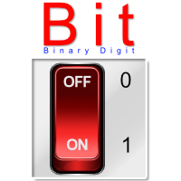

A Bit is…
Remember how computer sees data as a series of switches?
Well, if you take one switch it can only hold 2 possible positions - namely Off and On. This is represented as a '0' or a '1'.
This is exactly the number of possible values of a binary digit.
Shorten that to bi(nary) (digi)t and you have bit.

What is a Byte?
Click the icon in the top right corner of this box to find out.
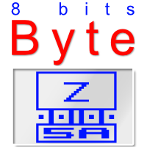

A Byte is…
To explain the concept of a Byte I need you to think about the extended ASCII table shown in the ASCII section (
click here to see the table
)
The table holds 256 characters - which is exactly the range of numbers that can be represented by a group of 8 binary digits (bits).
This grouping of 8 bits was formalised as a Byte.
Byte has no specific meaning - but knowing computer geeks it has its origin in a bad pun on the fact that it is bigger than a bit.
This is supported by the fact that they called half a Byte (i.e. 4 bits) a Nibble (feel free to groan).
Because a byte can represent a single character, it was standardised as the default measurement of storage and memory.
NB: The smallest space that data can take up in memory is 1 Byte.

If a Byte is the smallest unit in memory - what is the smallest unit for a storage device?
On a storage medium the smallest useable space depends on the smallest cluster size of the OS's file management system.
For Windows 10, macOS and Linux the default cluster size is 4 KB.
This means that if your file only contains 1 Byte of data it will still take up 4 KB of space on your storage medium.

Collections / Multiples of Bytes
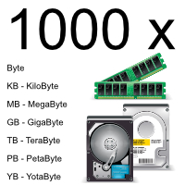
People work in Decimal - and we like to measure things in groups of 10:
10 mm = 1 cm. 100 cm = 1 m. 1000m = 1 km - and so on.
So it makes sense that we would use the same kind of system for measuring amounts of computer storage.
We collect computer storage in groups of 1000 - so from a byte we go to 1000 bytes.
Just like 1000 metres is a Kilometre, 1000 Bytes becomes a Kilobyte.

Computers work in binary.
The closest binary gets to a nice round 1000 is 1024 - 2(10).
So, technically, a Kilobyte is actually 1024 bytes.
The IEC (International Eletrotechnical Commission) standards body has actually ruled that the term 'kilobyte' can be regarded as 1000 bytes - and that the multipliers for storage can be 1000 instead of 1024.
We will stick with the 1000 multiplier for this reason.
A list of storage sizes for computing devices…
1000 Bytes = 1 KB (KiloByte)
1000 KB = 1 MB (MegaByte)
1000 MB = 1 GB (GigaByte)
1000 GB = 1 TB (TeraByte)
1000 TB = 1 PB (PetaByte)
1000 PB = 1 YB (YotaByte)
And that's as far as we'll go for now.
These are the terms are used to describe the capacity of storage and memory.

Video Links - Data Storage (bits, bytes, ASCII, etc)
We have selected and curated a set of videos on YouTube related to your course.
These videos are not created or owned by us.
They may display advertising and in some cases may contain limited amounts of swearing.

Notes for this Module
What to look out for and do in this module...

FAQs for this module
Questions on Bits and Bytes - and their answers...

Network Types FAQ
View the questions or type in the term you are looking for below…
No results were found

What is a Bit?
A Binary Digit

What is a Byte?
A group of 8 bits

What is the smallest unit of memory?
A Byte.

Why did the byte become the standard unit of memory?
Because a Byte is the smalles number which is a power of two and which provides a big enough range of numbers to create a table to represent characters and instruction codes.

Is there really such a thing as a nibble?
Yes, it is half a byte.

What term is used groups bigger than a byte?
These are usually called 'words' - with the number of bits being used in front.
Most numver types used in programming todat are actually 64 bit words.

